Robot Framework Installation Guide

Table of Contents
1 Getting started 3
1.1 Introduction 3
1.2 Tools/Software required 3
1.3 Installation Process 3
2 Latest Updates 6
3 Change history 6

Getting started

Introduction
Robot Framework is a generic test automation framework for acceptance testing and acceptance test-driven development (ATDD). It has easy-to-use tabular test data syntax and it utilizes the keyword-driven testing approach. Its testing capabilities can be extended by test libraries implemented either with Python or Java, and users can create new higher-level keywords from existing ones using the same syntax that is used for creating test cases

Tools/Software required
This section covers the required tools and preconditions on the operating systems where the test suite is going to be executed. Below is the list of tools/software required for Robot Framework setup:
- Python
- Wxpython
- Robot framework
- RIDE
- Selenium2Library
- And other utility libraries mentioned in the document.

Installation Process

- Python Installation
Check if python is already installed on your machine or not.

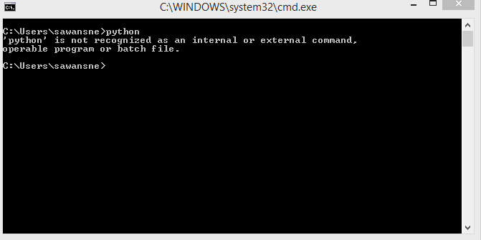

- Install Python version 2.7.6 in your system.
Set Python Path in in environment variable (C:\Python27)
After Python installation and setting python path:

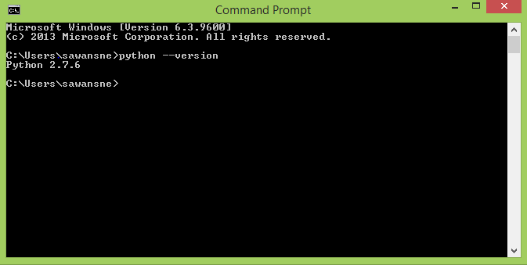

- Install wxpython

- Open CMD
CMD to install and uninstall the packages.
Add the following commands to install the packages:

- For installation of Robot Framework
Type the command: pip install robotframework
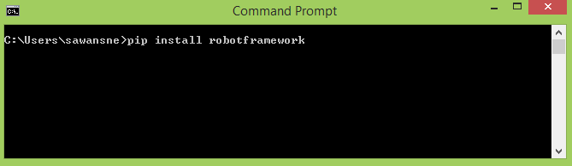

Run the command

- For installation of RIDE type command: pip install robotframework-ride

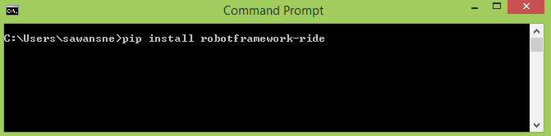

Run the command

- For installation of Selenium2Library type command:
pip install robotframework-selenium2library
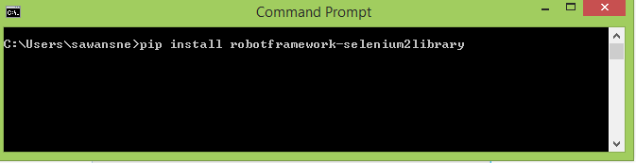

Run the command
Similarly we can install other libraries in the system.

# Install the latest version
pip install robotframework

Other Commands:-
# Upgrade to the latest version
pip install --upgrade robotframework

# Install a specific version
pip install robotframework==2.9.2

# Install separately downloaded package (no network connection needed)
pip install robotframework-3.0.tar.gz

# Uninstall
pip uninstall robotframework

# Install the latest version of Selenium2Library
pip install robotframework-selenium2library

# Install the latest version of RIDE
pip install robotframework-ride

# Install the latest version of Excel Libraries
pip install robotframework-excellibrary

Latest Updates

Now, Robot Framework does support both Python 2 and 3. Still they have decided to continue support Python 2 till it’s available.

Note:-
- If you are using Python 3, pip comes with its setup. Hence no need to install pip additionally for it.
- Option is also available to set PATH for Python 3 setup.
Please find few pip commands for installation of few libraries/modules which are required for the developed Unified TA Framework for Robot Framework.

Other Installations
Below are the pip commands to be used to install and use various libraries that are available for Robot framework. Syntax is “pip install <library-name>”. These are libraries/modules that have been used while creation of the framework. There are various libraries available. User can install those from internet and use according to their convenience.
- For Database: pip install robotframework-databaselibrary
- For MySQL: pip install PyMySQL==0.7.11
- For Parallel Execution: pip install robotframework-pabot
- For Excel related operations:
  - pip install xlrd
  - pip install pyexcel
  - pip install robotframework-excellibrary
  - pip install XlsxWriter
  - pip install xlutils
- For Mailing Library: pip install win32com
- For Jira Connection: pip install JiraRobot

Integration with Tools
- Application Lifecycle Management:
For integration of Robot framework with ALM, please refer to the below document on GiT repository:
“Robot Framework-ALM Integration.doc”
- Jenkins
For integration of Robot framework with Jenkins, please refer to the below document on GiT repository:
“Robot Framework-Jenkins Integration.doc”
- Jira
For Jira integration, there is no separate configuration required. Installing “JiraRobot” library will help the user to connect and update Jira.
- Microsoft Outlook
Miicrosoft outlook integration is done using the MAPI interface in python. As mentioned above in Other Installations section, win32com module needs to be installed to use MAPI interface.

3 Change history

Version | Date | Author | Reviewed by | Approved by | Change history
1.0 | 10.30.2017 | Snehal Sawant |  |  | Created the document -- Draft Version

